Matthew Schreider & Joshua Culver

James Atlas

Cisc181 Game Project

May 19, 2014

**Basket Case Game**

**Summary:**

The objective of the game is to achieve the highest score possible before dying. The player or AI will be able to control a basket located at the bottom of the screen. While the game is running, many fruits and enemies will be falling from the top of the screen at random locations. The player or AI will try to collect the fruits that are falling into the basket. This can be done by moving the basket directly underneath the item that is falling. However, if the player or AI catches an enemy, there will be a penalty.

**Rules:**

Apple: 5 points

Strawberry: 1 point

Orange: 5 points

Watermelon: 10 points

Banana: 3 points

Rock: -25 points

Beehive: -1 Lives

Bomb: Game Over

After the first 20 seconds, the person playing will have to catch only specific types of fruit or legal fruits. If they catch a fruit that is not one of the specific fruits or a fruit that is Not Legal, then they will lose the amount of points of the fruit that they caught. The player is not allowed to move off the screen. There is a main screen with a highscore database.

We used this code to set an image as the background: http://stackoverflow.com/questions/21005529/how-to-set-external-images-as-background-for-an-app-layout

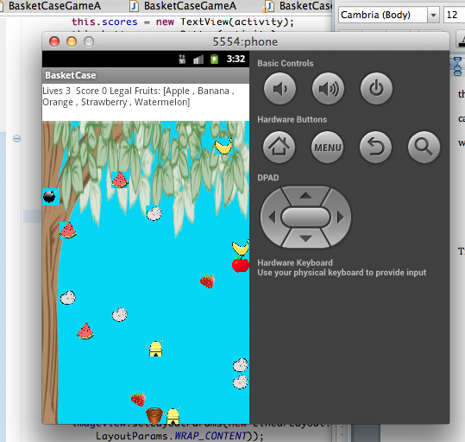

Tree picture: <http://www.d91.net/Biodiversity/tree_border_top2.gif>

Apple picture: http://bestclipartblog.com/23-apple-clip-art.html/Apple-clip-art-10

Banana picture: http://www.clipartbest.com/clipart-niEeKGXiA

Orange picture http://www.clipartbest.com/clipart-9aTqR4LiM

Strawberry picture: http://all-free-download.com/free-vector/vector-clip-art/strawberry_clip_art_12891.html

Watermelon picture: http://bestclipartblog.com/30-watermelon-clip-art.html/Watermelon-clip-art-1

Bomb picture: http://www.clker.com/clipart-black-bomb.html

Rock picture: http://www.clipsahoy.com/nature/rocks/rocks1.htm

Beehive picture: http://www.acclaimclipart.com/free_clipart_images/beehive_with_honey_bees_swarming_about_0071-0812-2316-5952.html

Basket picture: http://www.clker.com/clipart-basket-no-handle.html